**Facial Expression analysis**

**Dataset details**

The images selected for analysis are recorded from NICU at MSRTH using Wi-Fi camera and mobile camera. NICU includes both full term and preterm neonates with gestation age ranging from 28-37 weeks and with varied health conditions. Different activities of the baby are recorded which includes cries and sleep of the baby using Fingers 1080 Hi-Res Webcam Videos are recorded at a frame rate of 30 fps.

|  |  |  |  |  |  |  |
| --- | --- | --- | --- | --- | --- | --- |
| **PATIENT ID** | **Gender** | **Gestation Week** | **Duration of recording** | **Frame Rate** | **Camera used for recording** | **Diagnosis** |
| PTV001 | M | 34 weeks | 00.03.00 | 30fps | Wifi camera | PT |
| PTV017 | M | 37 weeks | 00.03.00 | 30fps | Mobile | PT/AGA/M |
| PTV018 | F | 28 weeks | 00.03.00 | 30fps | Mobile | PT/AGA/RDS |
| PTV016 | M | 32 weeks | 00.03.00 | 30fps | Wifi camera | Preterm / Perinatal Depression |
| PTV015 | F | 32 weeks | 00.03.00 | 30fps | Mobile | Late PT/AGA |
| FTV003 | F | 40 weeks | 00.03.00 | 30fps | Mobile | Term/SGA/Male/Congenital Hydrocephalus |
| FTV001 | M | 37 Weeks | 00.03.00 | 30fps | Wifi camera | Term /AGA/ MAS |
| FTV002 | F | 40 weeks | 00.03.00 | 30fps | Wifi camera | Term /AGA/ MSAF |
| FTV004 | M | 42 weeks | 00.03.00 | 30fps | Mobile | Term/AGA/Pneumonia |
| FTV005 | F | 42 weeks | 00.03.00 | 30fps | Mobile | Term/AGA |

**Open-source database details**

The Infant COPE Database, contains 204 facial images of 26 neonates experiencing the pain of a heel lance and three nonpain stressors: transport from one crib to another (a stressor that triggers crying that is not in response to pain), an air stimulus on the nose (a stressor that provokes eye squeeze), and friction on the surface of the heel (a stressor that produces facial expressions of distress that are similar to the expressions of pain). In addition to these four facial displays, the database includes images of the neonates in the neutral state of rest.

For facial expression analysis, videos are first converted into frames. 20% of frames are taken for analysis. These frames are then selected based on following criteria

(a)**Case A** - Selecting Random frames -20% of frames are taken for analysis by considering first, mid and last frame.

(b) **Case B**- Selecting frames based on SSIM (Structural Similarity Index) values by varying threshold values. ‘I’ is taken as reference frame, SSIM is performed by varying threshold values (0.67, 0.77,0.87). 20 frames are selected.

(c)**Case C**- Selection based on Correlation and PSNR values.

For motion estimation entire video is considered for analysis

**Automatic Face detection for emotion recognition**

* Automatic face detection is tested using Viola Johns algorithm, local SMQT features and split up SNoW classifier, KLT algorithms. These algorithms do not detect the baby’s face effectively.

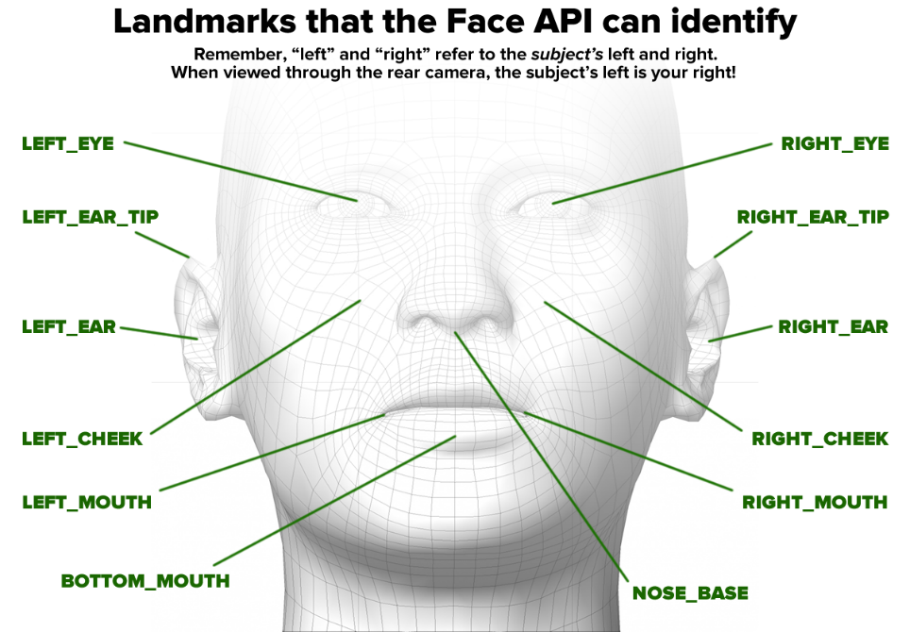

Figure 1 Landmarks identified by face detection algorithms

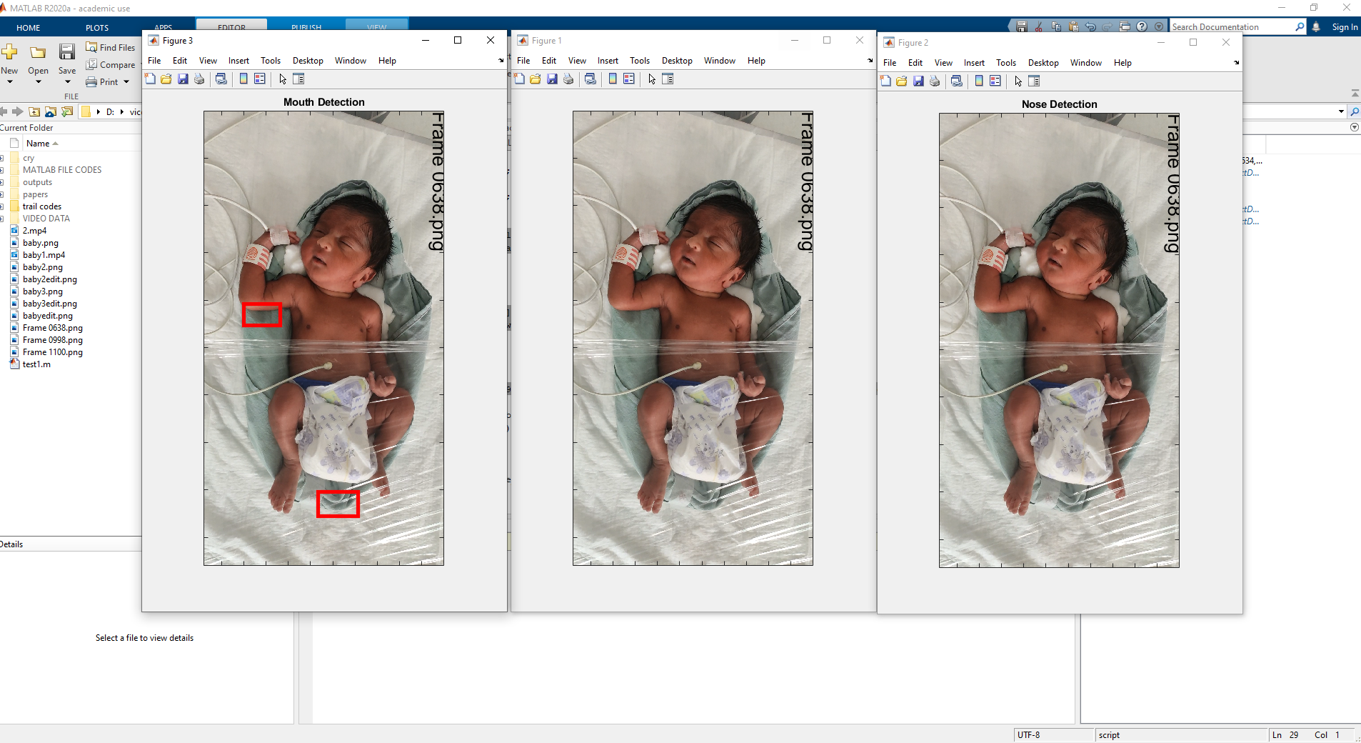

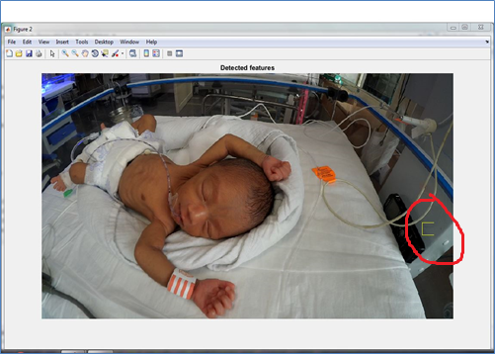

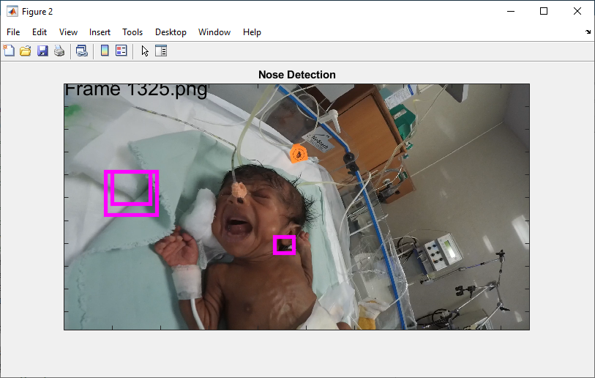

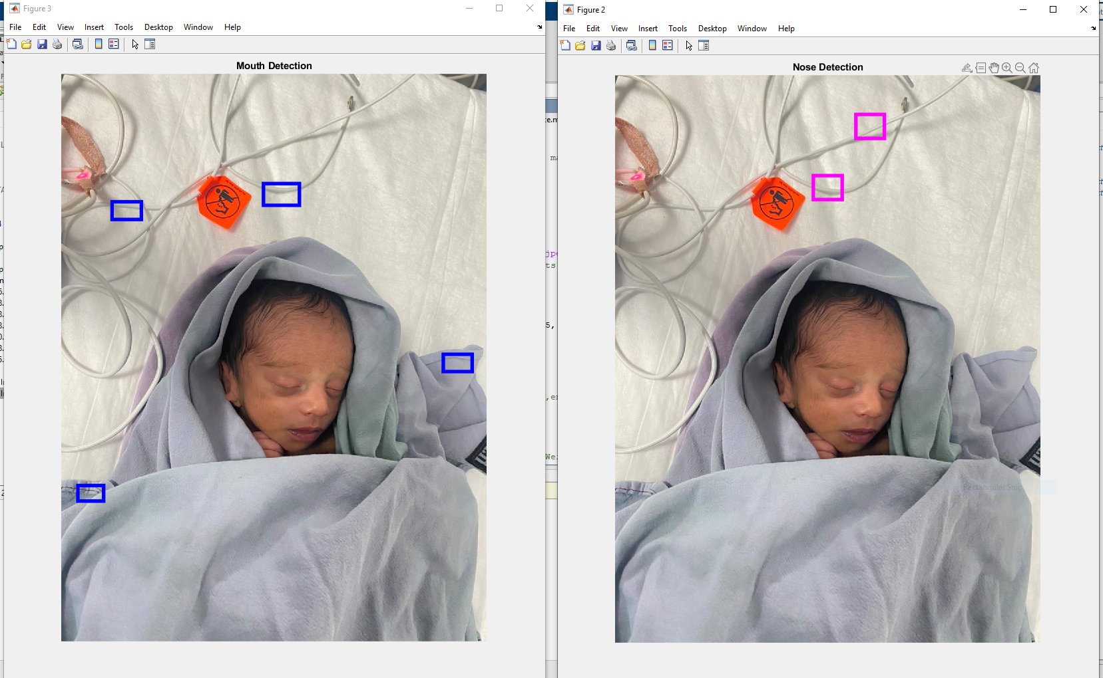

* Where as algorithm detects the human faces and full-term baby faces effectively because of well distinguished facial features.

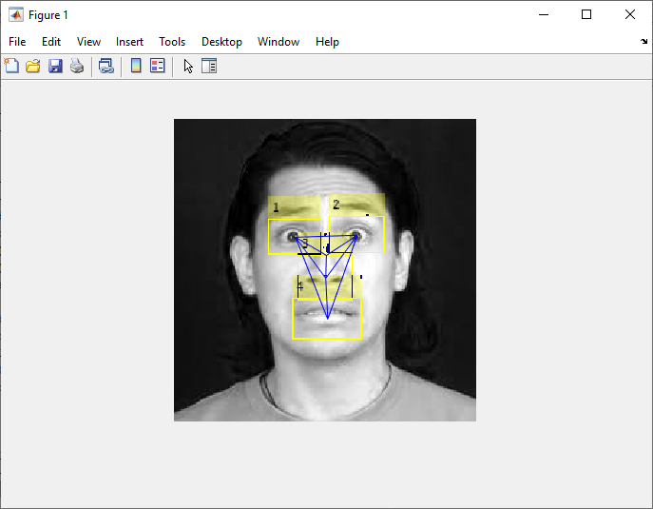

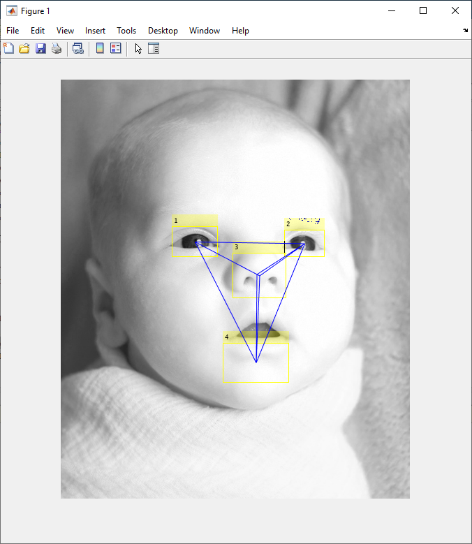

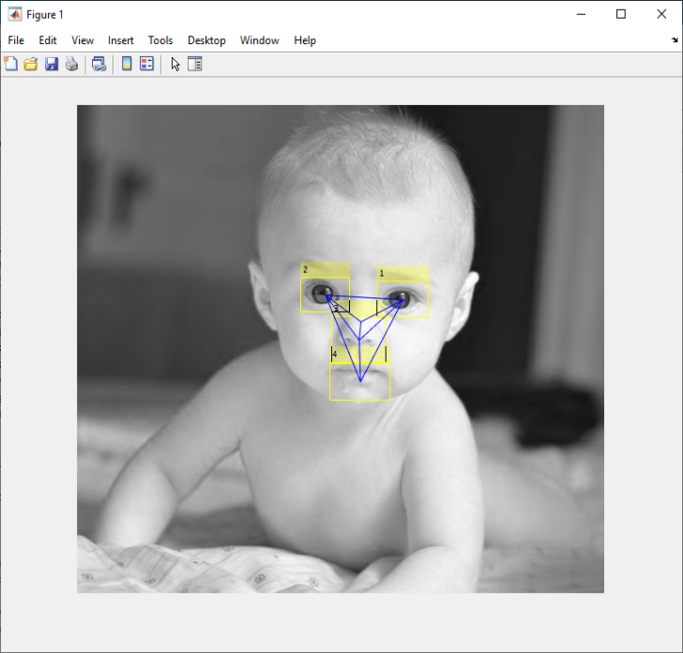

**Detecting facial features which includes face detection, non-skin region extraction and morphological processing**

**(**Image Processing Techniques To Recognize Facial Emotions, A. Mercy Rani et,al 2017)

The images selected for analysis are taken from online sources and images collected from MSRMH.

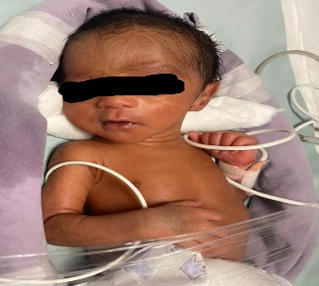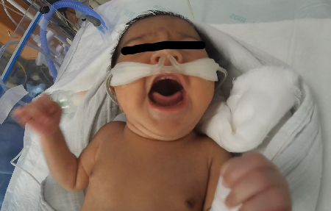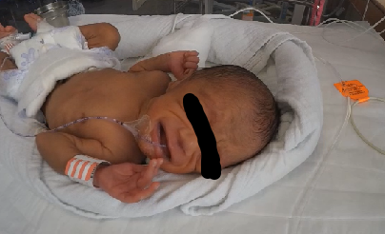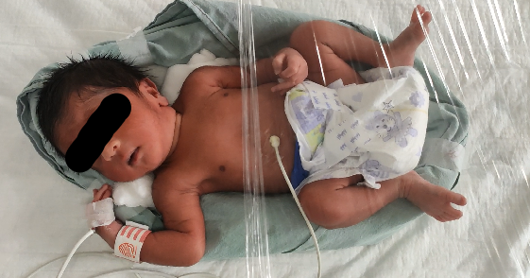

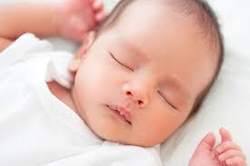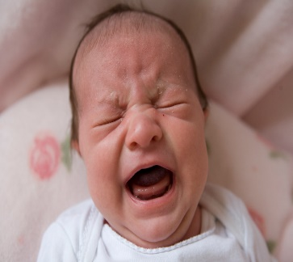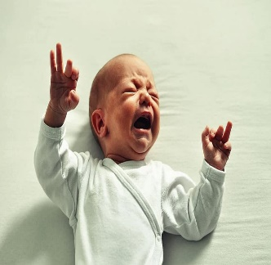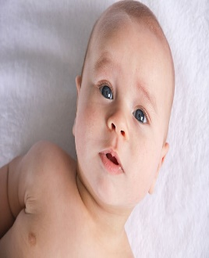

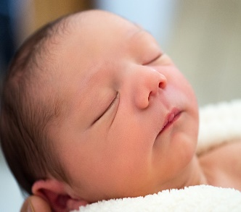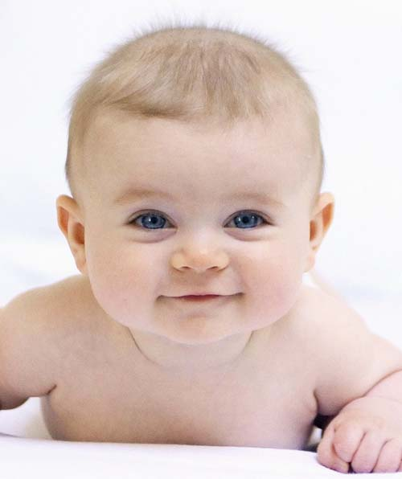

Analysis is done using MATLAB. Algorithm is as mentioned below,

* Read the input video frame image
* Convert the image into grayscale image.
* Enhance the input image with median, wiener and gaussian filters.
* Find the best filter based on PSNR, RMSE values.
* Apply viola-jones algorithm to detect the face region.
* Use bounding box method and crop the face region.
* Use threshold value to extract non skin regions.
* Apply morphological operations to extract continuous boundaries of non-skin region.
* Mask the boundary from the original image.
* Extract the mouth region.
* Area is calculated from extracted mouth region.
* Recognize facial emotions based on the value of area.

**Outputs**

   

 

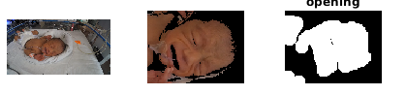 

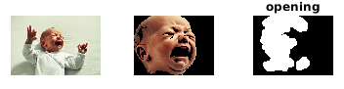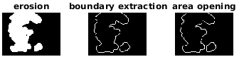

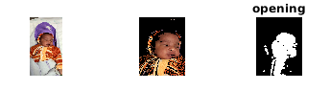 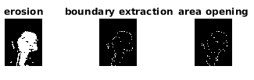

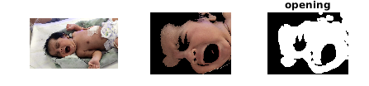 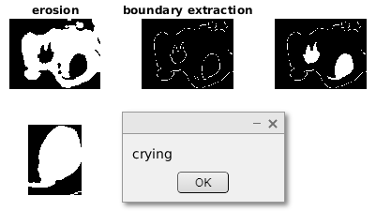

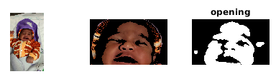 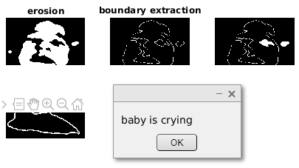

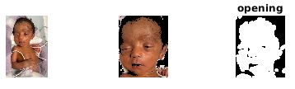

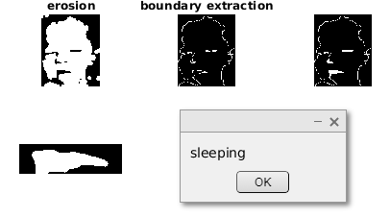

**Results**

Infant face images are extracted from recorded video from NICU and downloaded from online sources. Viola johns algorithm is used to detect baby face. The images taken in this study consists of preterm and full-term babies and facial features of babies are not well distinguished. Hence Viola john’s algorithm fails to detect baby face. Instead of that crop feature can be used. Algorithm classifies images as neutral, sleeping and crying categories. Algorithm needs to be tested on a greater number of images for better accuracy. With the available data it is found that the proposed algorithm works well for images recorded from mobile camera.

**Classification results**

* Support vector machine (SVM) is used for classification.
* Video data collected from NICU at MSRH are annotated and labelled into three classes i.e., Moderate, None and Severe pain based on the Wong bakers pain scale.
* Moderate, none and severe are the three classes.



* Some of the key parameters in SVM are:

→Gamma: defines how far the influence of single training examples reaches values leads to biased results.

→ C: Controls the cost of miscalculations

Small C — makes the cost of misclassification LOW

Large C — makes the cost of misclassification HIGH

→ Kernel: SVM algorithms use a set of mathematical functions that are defined as the kernel.

* RBF (Radial Basis Function), Polynomial Kernel are deployed.



Below are results of classifier

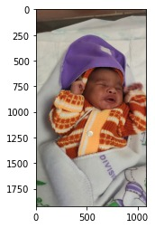

**moderate = 95.3253408163106%**

**None = 2.420899909551253%**

**severe = 2.2537592741381443%**

**The predicted image is: moderate**

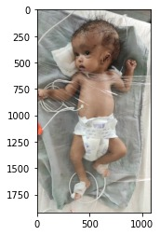

**moderate = 25.095100341583905%**

**None = 60.30653489330289%**

**severe = 14.598364765113189%**

**The predicted image is: None**

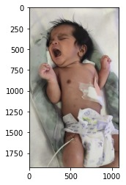

**moderate = 8.648209596205698%**

**None = 3.2216067411114846%**

**severe = 88.13018366268282%**

**The predicted image is: Severe**

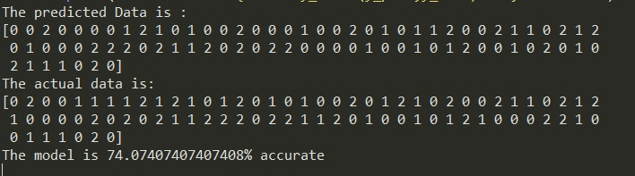

* Model is also tested for completely unknown data

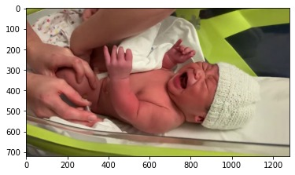

**moderate = 40.38214589165237%**

**None = 20.109537893228474%**

**severe = 39.50831621511915%**

**The predicted image is: moderate**

**recall score for all three classes (0.7773809523809524, 0.7374162381175005, 0.7483076755104269)**

* Algorithm gives **74%** accuracy.

**Method 2**

**Classes**: Hunger, Discomfort and Pain for open source database.

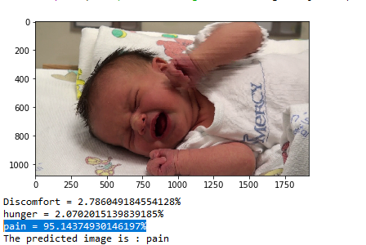

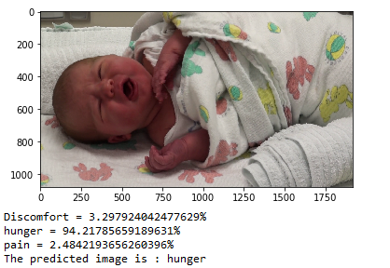

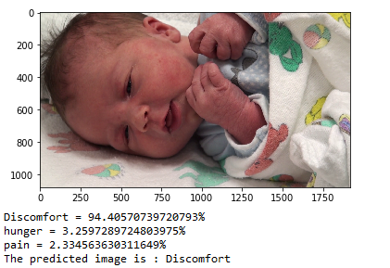

**Method 3**

**Classes:** Pain and no pain for open source database.

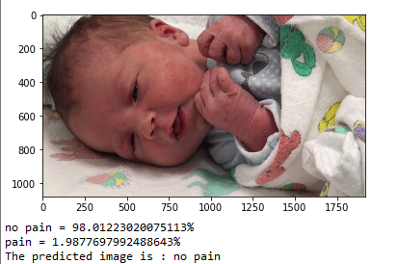

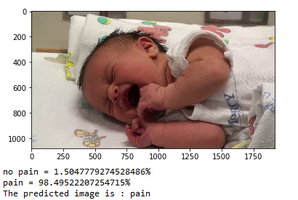

**HOG and Gabor features**

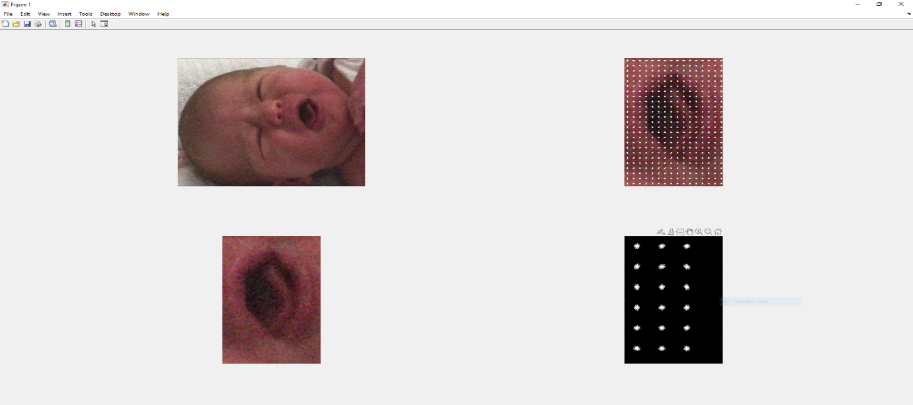

HOG feature for Moderate pain

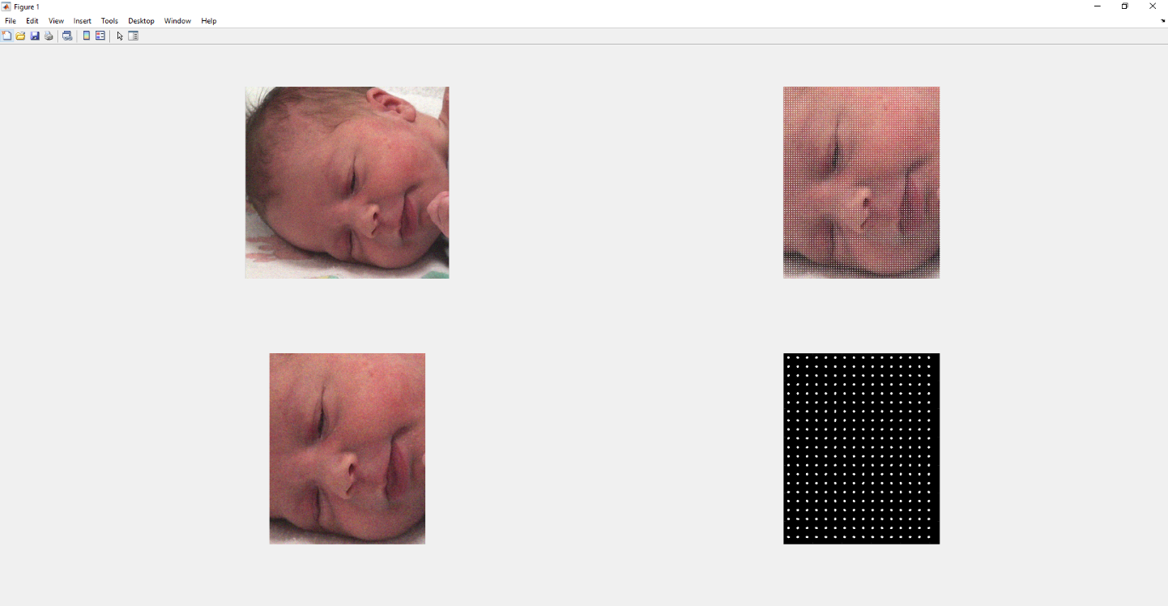

HOG feature for No pain

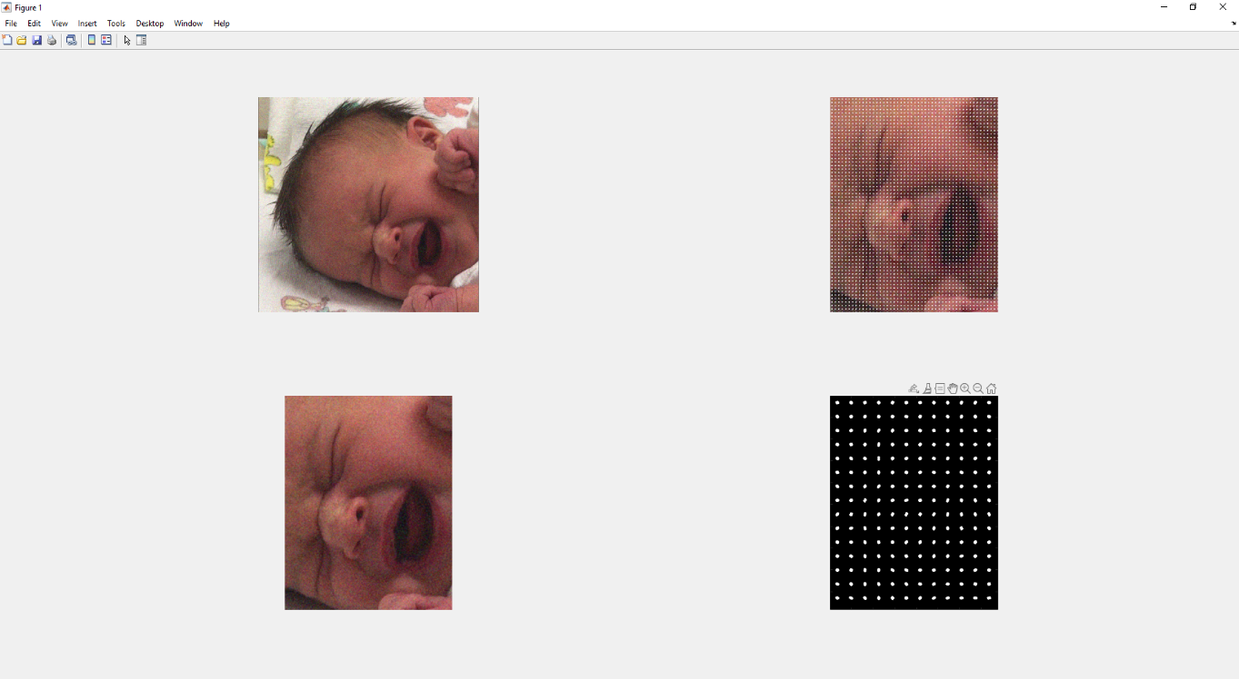

HOG feature for Severe pain

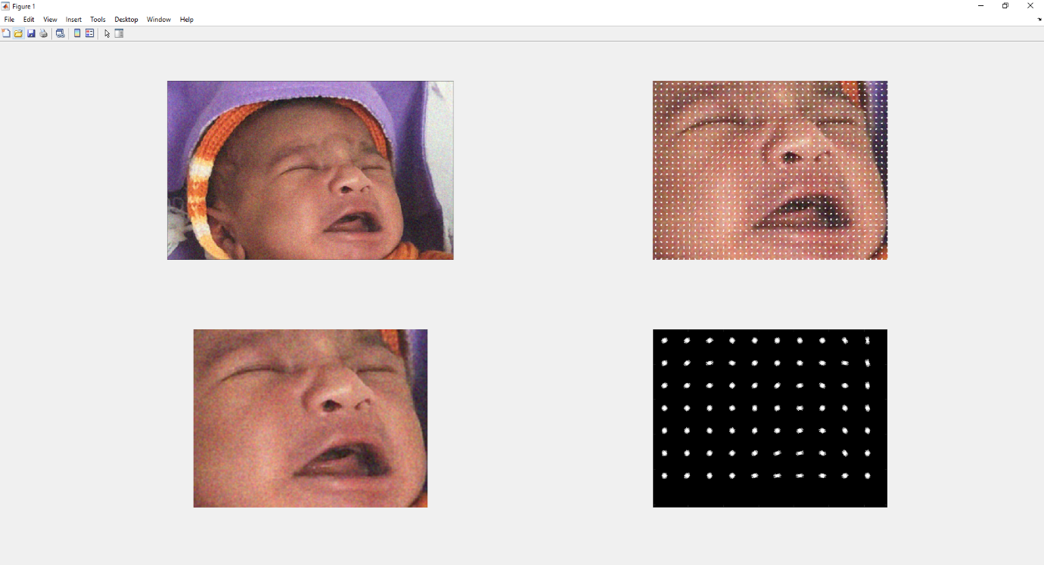

HOG feature for Moderate pain

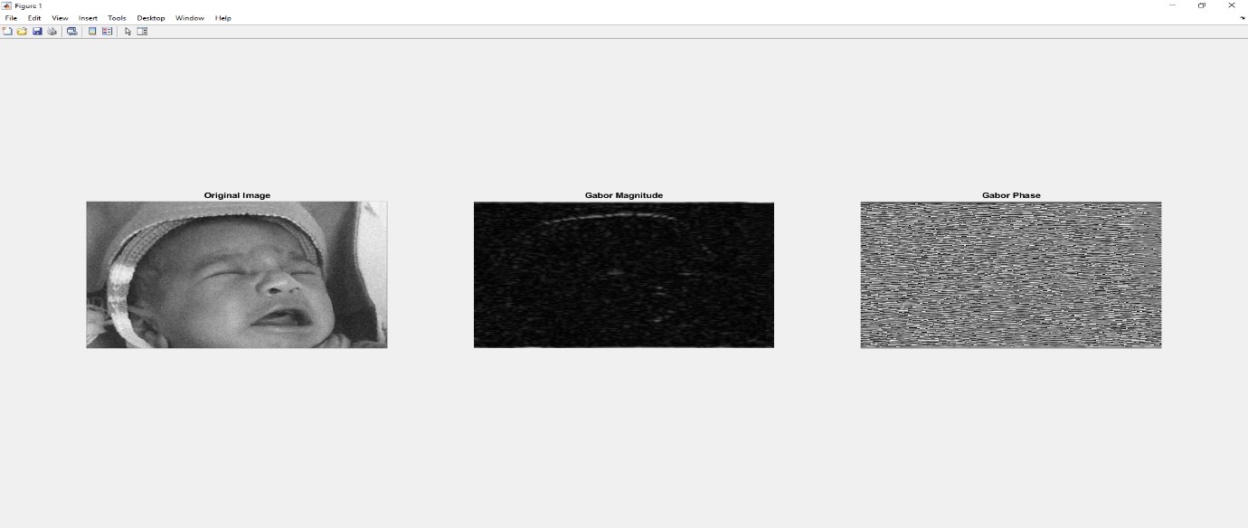

Gabor magnitude and phase for moderate pain

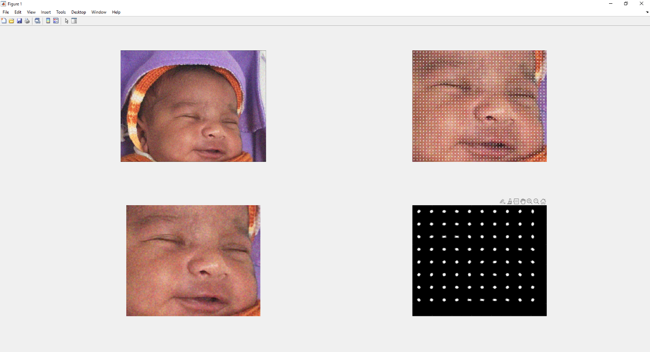

HOG feature for no pain

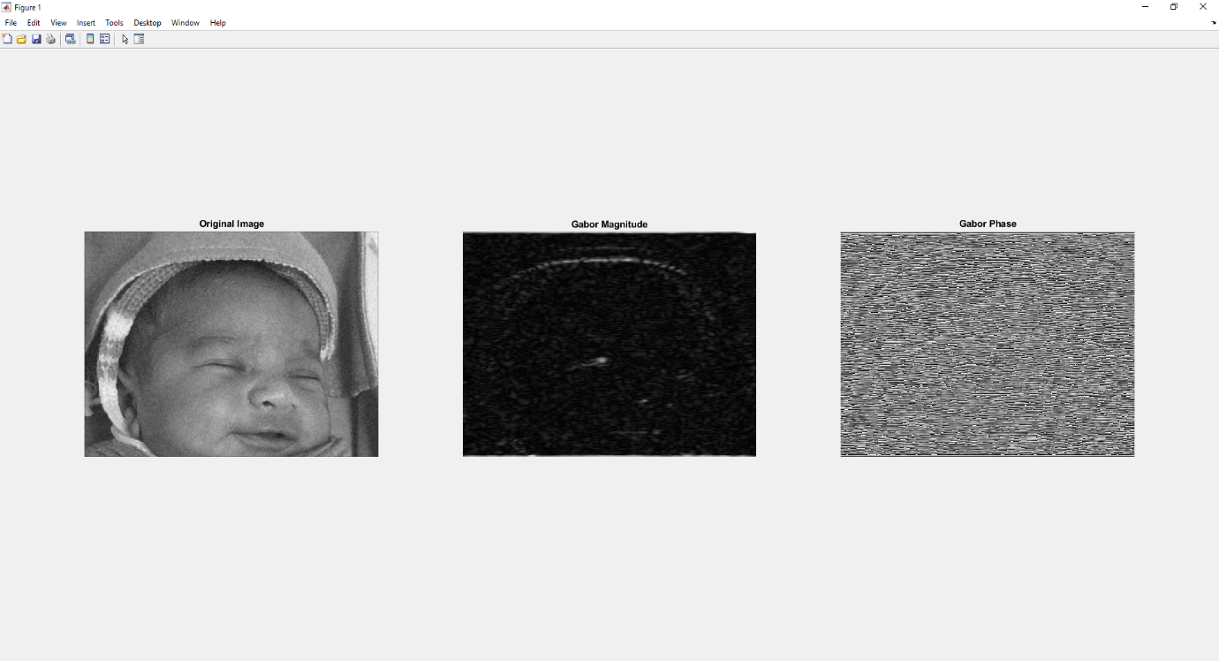

Gabor magnitude and phase for no pain

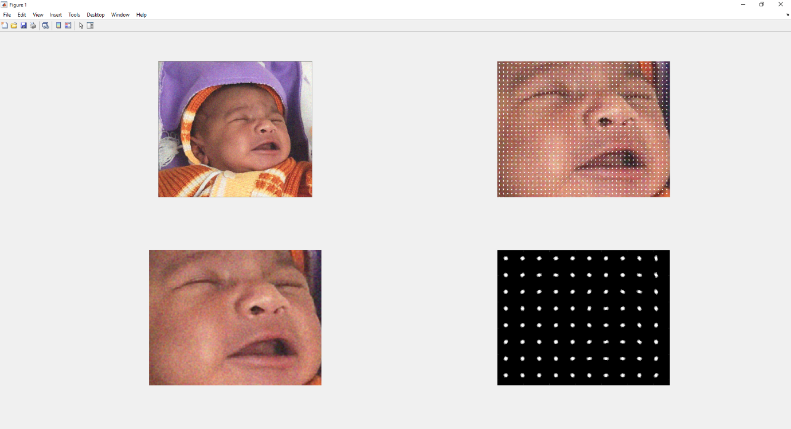

HOG feature for severe pain

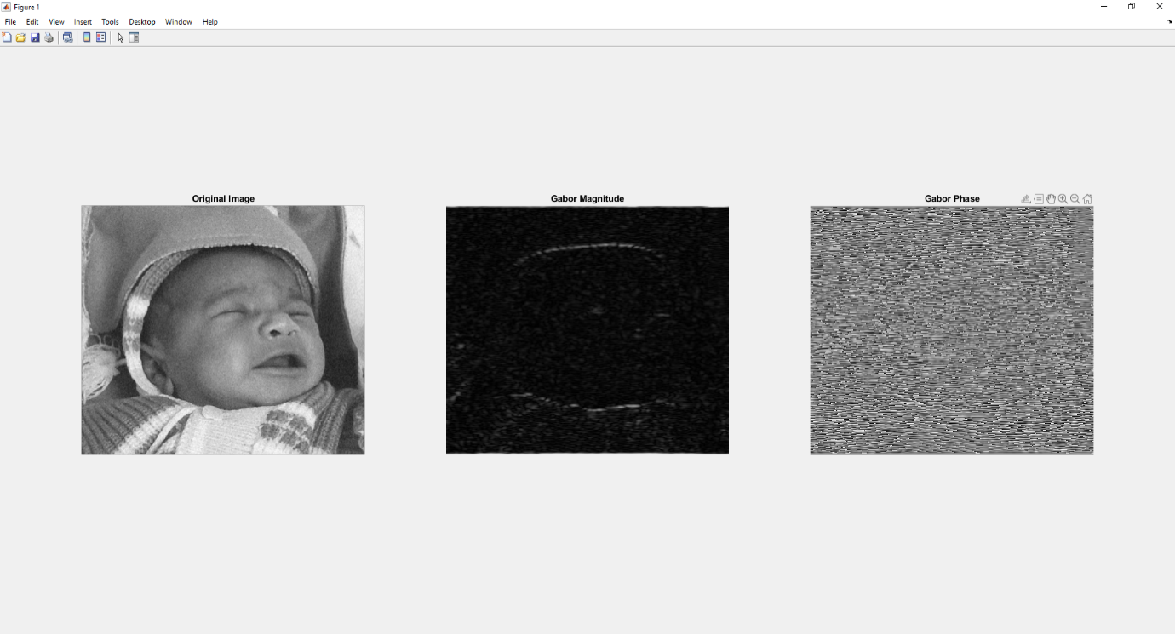

Gabor magnitude and phase for severe pain